Workflow mouse brain registration and cell counting

Requirements:

* Matlab
* Fiji
* SharpTrack, includes a link to Allen brain Atlas annotations: <https://github.com/cortex-lab/allenCCF/wiki/1.-Requirements>

The ShaprTrack wiki is quite nice, read it to get acquainted with the tool before starting to use it.

* Fiji macros: pre_processing_IF.ijm, cell_counting_IF.ijm

Summary: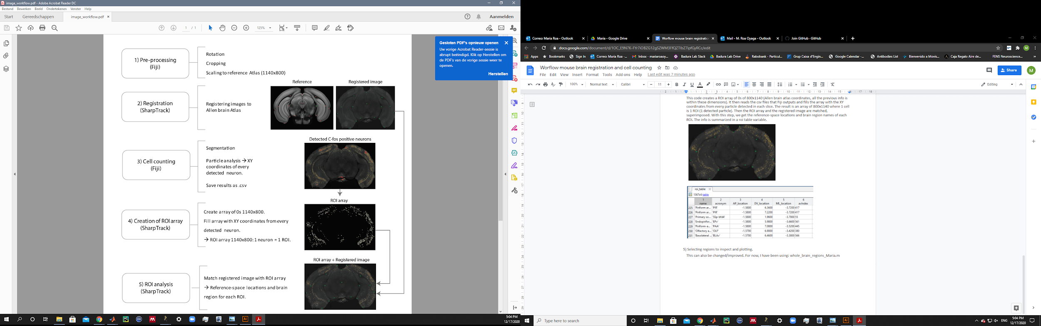

1. **Pre-processing – macro in Fiji**

*Run macro preprocessing_IF.ijm in Fiji*

Most of the steps are automatic but the following ones require manual user input.

* Rotation: If the slice is tilted, use the pop up window to adjust the angle of the slice. IMP: make sure you click preview to see the changes you are applying.
* Cropping: to get rid of extra black pixels. Leave some space on top and bottom of the image when cropping. The sides can be totally cropped, near the slice. See example below.

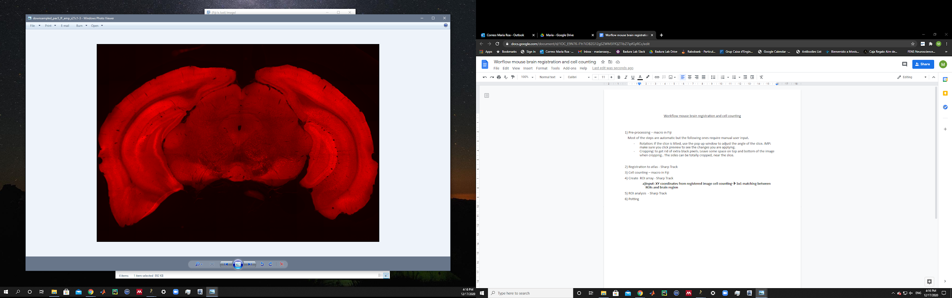

1. **Registration to atlas - Sharp Track, Matlab**

*Run code Navigate_Atlas_and_Register_Slices.m in Matlab*

Registering each slice to the coordinate system of the Allen brain atlas. This is done slice by slice by clicking a point in the reference atlas and then selecting the equivalent point in the real slice.

IMP: Use the arrows in your keyboard to change orientation direction (anterior-posterior, dorso-ventral or medio-lateral). Choose the most similar orientation to match your slice.

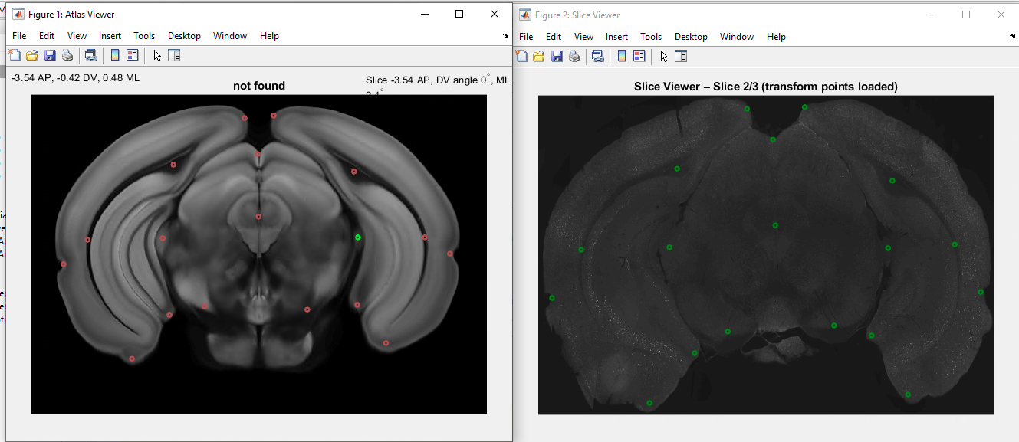

There are different viewing options, you can toggle them by using the following controls.

The first times using this tool it might be a bit confusing, but eventually you get used to it!

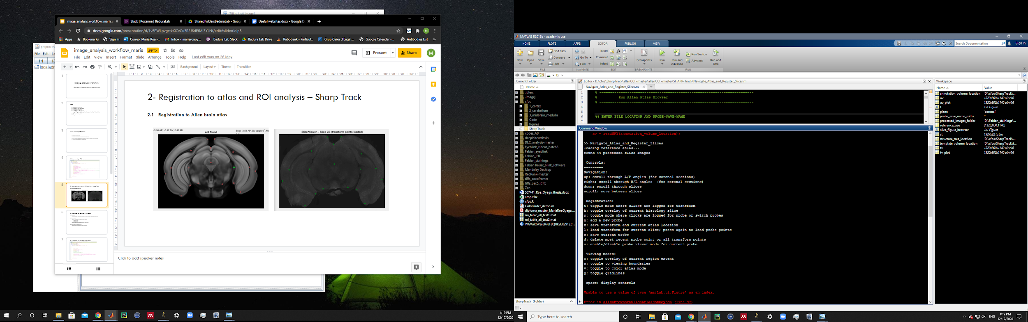

1. **Cell counting – macro in Fiji**

*Run macro called cell_counting_IF in Fiji*

Select the folder where the transformed images are (the ones that have been registered to the Allen brain atlas).

→ Still working on the thresholding method.

This macro applies a threshold for segmentation, and uses the fiji function particle analysis to count all particles detected above the determined threshold. Different parameters can be adjusted within the code. It returns a csv file with the X and Y coordinates of the most centric pixel in each detected particle.

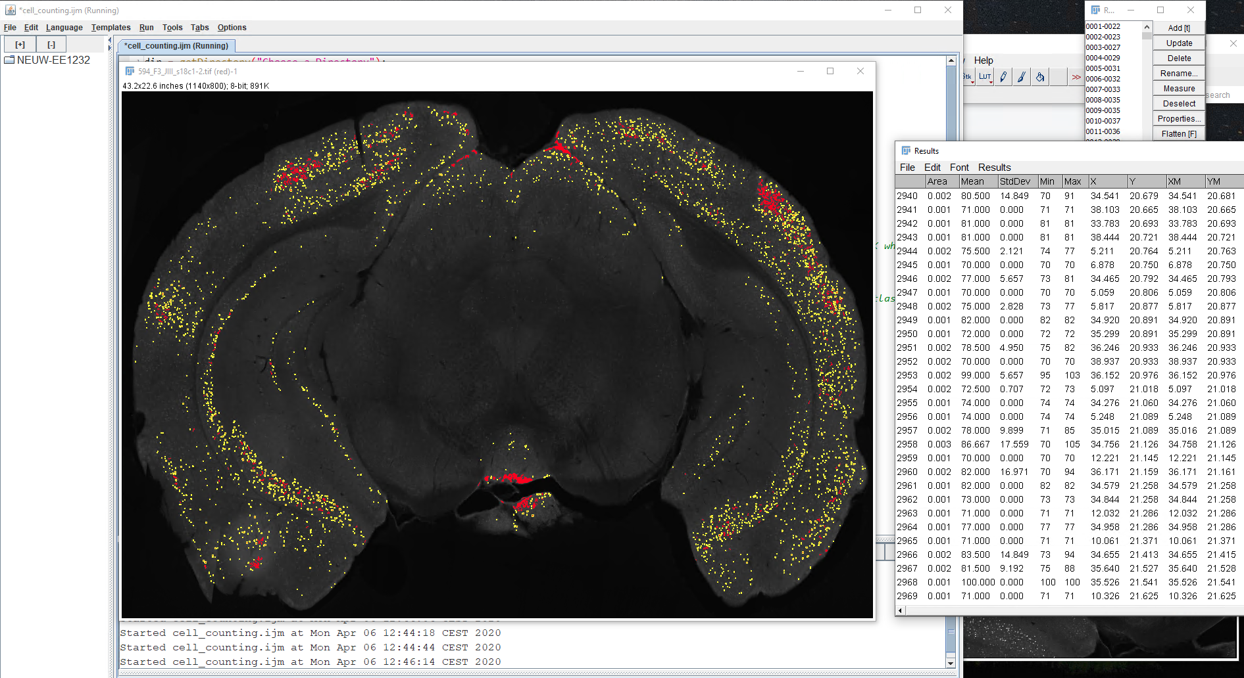

1. **Creation of ROI array and matching to Atlas - Sharp Track, Matlab**

*Run Analyze_ROIs_new. M in Matlab*

This code creates a ROI array of 0s of 800x1140 (Allen brain atlas coordinates, all the previous info is within these dimensions). It then reads the csv files that Fiji outputs and fills the array with the XY coordinates from every particle detected in each slice. The result is an array of 800x1140 where 1 cell is 1 ROI (1 detected particle). Then the ROI array and the registered image are matched, superimposed. With this step, we get the reference-space locations and brain region names of each ROI. The info is summarized in a roi table variable.

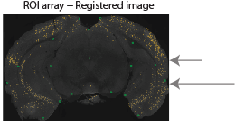

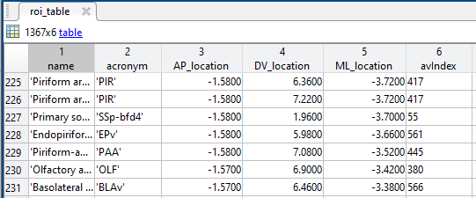

1. Selecting regions to inspect and plotting.

This can also be changed/improved. For now, I have been using: whole_brain_regions_Maria.m